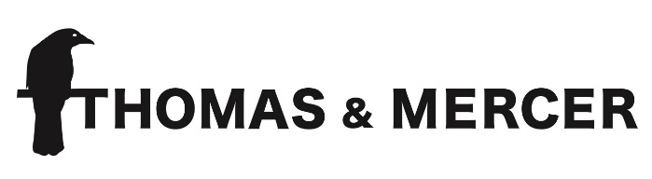

Contact:
Elena Stokes, Wunderkind PR Delia Shankey
917.887.0784 845.480.4894
elena@wunderkind-pr.com delia@wunderkind-pr.com
Blood on the Tracks
By Barbara Nickless
ADVANCE PRAISE FOR BLOOD ON THE TRACKS

“A stunner of a thriller. From the first page to the last, Blood on the Tracks weaves a spell that only a natural storyteller can master. And a guarantee: you'll fall in love with one of the best characters to come along in modern thriller fiction, Sydney Rose Parnell.”
—Jeffery Deaver, bestselling author of The Steel Kiss

“Nickless’s writing admirably captures the fallout from a war where even survivors are trapped, forever reliving their trauma.”
—Kirkus Reviews

“Part mystery, part antiwar story, Nickless’s engrossing first novel, a series launch, introduces Sydney Rose Parnell...Nickless skillfully explores the dehumanizing effects resulting from the unspeakable cruelties of wartime as well as the part played by the loyalty soldiers owe to family and each other under stressful circumstances.”
—Publishers Weekly

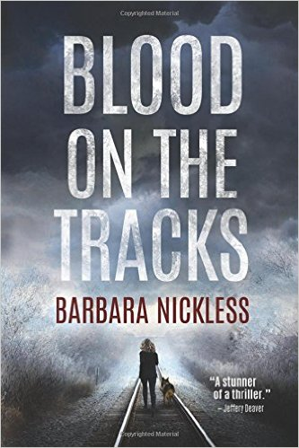
From acclaimed short story author and essayist Barbara Nickless comes the debut novel, BLOOD ON THE TRACKS (Thomas & Mercer; $15.95 Trade Paperback Original; $4.99 Ebook; October 4, 2016), a gritty tour de force that’s already won the Daphne du Maurier Award and was a runner-up for the Claymore Award.

Sydney Rose Parnell is a young veteran, home after two tours in Iraq. Now, she’s spends time with her family, works as a railway cop with her K9 partner, Clyde (also a veteran), is enrolled in community college and trying to figure life out, all while haunted by the ghosts of her past in war—both literally and figuratively. All things considered, she’s doing fine…until a young woman is found brutally murdered.
The prime suspect is a fellow marine left hideously scarred from his time at war; he is known as the Burned Man, and he claims to not recall a thing about the murder…whether he did it or not.

All evidence points to the Burned Man’s guilt, but Parnell can’t shake the idea that there are more powerful forces at work in this case. And there’s something else driving her, too—a dark secret that she and the Burned Man share from their time at war that’s bigger than both of them.

A brilliant debut novel, BLOOD ON THE TRACKS is part murder-mystery, part war-story, and all thriller.

About Barbara Nickless
Born in Guam and now living in Colorado, Nickless promised her mother that she’d be a novelist when she grew up. What she didn’t mention at the time was the type of jobs she’d work beforehand: a technical writer, astronomy instructor, piano teacher, journalist, even a raptor rehabilitator and a swordfighter. In Colorado, she enjoys hiking, snowshoeing and drinking single malt scotch—usually not all at once.

As an author, Nickless’ short stories and essays have been published in anthologies in the United States and the United Kingdom. Blood on the Tracks is her debut novel (and signifies that she has officially kept her promise to her mother!).
Keep up with Nickless:
http://www.barbaranickless.com/
https://twitter.com/barbaranickless

An Excerpt from Blood on the Tracks
The front room was neat and tidy, dominated by the scarred oak table where tramps often sat to eat and talk. Two glasses of milk—one half drunk, the other untouched—sat on the table.
She’d been busy, he thought. Too busy to clean.
A week, she’d told him, I’ll be done with everything else.
In the kitchen, morning light splayed across the linoleum. A third glass was overturned on the counter, a dribble of milk splotched down the side of the sink. Seeing that glass, the Burned Man tried to close his hands around the stock of a rifle he no longer carried, his sense of wrong growing until it lifted the hairs on the nape of his neck. He grabbed a knife from the drawer near the stove and walked down the hallway beyond, telling himself maybe she wasn’t here. Maybe she had changed her mind about him and fled before he arrived.
The air grew colder. In Elise’s small guestroom, the bed was made, a stuffed Tweetie Bird staring blankly from a mound of gingham pillows. From the nightstand he picked up a picture of himself and Elise taken before his deployment, her smile sweet, his expression cocky—unlined, unmarred, unscarred.
Back then he’d believed nothing could touch him.
Some instinct made him slide the photo, frame and all, into his ruck. As if already she was slipping away from him, and he had to grab this one thing. He went back into the hallway. Wind rattled the closed door of Elise’s bedroom, and a draft came though, making his heart race. He closed his eyes before he opened the door.
“Elise?”
He walked in.
“You did this!” the man shouted through the Iraqi interpreter. He pointed at the dead woman lying in the street. Her body was stiff and fly-ridden, like she’d been there for a day or two.
“You killed her! I saw you!”
“Wasn’t me, man.” Tucker looked at the ‘terp. “Tell him. We wasn’t anywhere near here.”
But part of him wasn’t sure. They’d driven a patrol down this same street yesterday, and he’d opened fire from the turret of the Humvee when he heard a sharp click and thought maybe someone was triggering a bomb. Everyone was so damned afraid of the IEDs, those fucking human incinerators that ripped a man to hell and left him there.
So Tucker had reacted to that loud, metallic click. Or not so much Tucker, but his trigger finger, which didn’t need Tucker to give it instructions. It knew how to survive.
“It wasn’t me!” he shouted. “Wasn’t me!”
“Wasn’t me,” he sobbed.
He looked down. In his hand was a knife, bloodied. Nearby, a filthy urinal and a dripping sink and a sign by the door telling employees to wash their hands.
Where was he? And where was Elise? What—?
What had he done?

*******************************************************************

Blood on the Tracks by Barbara Nickless
On sale: October 4, 2016 · Thomas & Mercer · $4.99 Ebook
384 pgs ·$15.95 Trade Paperback Original · ISBN-13: 978-1503936867

*******************************************************************

For more information or to schedule an interview with Barbara Nickless, please contact:
--Elena Stokes at elena@wunderkind-pr.com / 917.887.0784

More Praise for Blood on the Tracks

“Blood on the Tracks is a must-read debut. A suspenseful crime thriller with propulsive action, masterful writing, and a tough-as-nails cop, Sydney Rose Parnell. Readers will want more.”
—Robert K. Tanenbaum, New York Times bestselling author of the Butch Karp/Marlene Ciampi legal thrillers

“Both evocative and self-assured, Barbara Nickless’s debut novel is an outstanding, hard-hitting story so gritty and real you feel it in your teeth. Do yourself a favor and give this bright talent a read.”
—John Hart, multiple Edgar Award winner and New York Times bestselling author of Redemption Road

Praise for Blood on the Tracks (continued)

“An interesting tale...The fast pace will leave you finished in no time. Nickless seamlessly ties everything together with a shocking ending.”
—RT Book Reviews

“Beautifully written and heartbreakingly intense, this terrific and original debut is unforgettable. Please do not miss Blood on the Tracks. It fearlessly explores our darkest and most vulnerable places—and is devastatingly good. Barbara Nickless is a star.”
—Hank Phillippi Ryan, Anthony, Agatha, and Mary Higgins Clark award winning author of Say No More (DC)

“Fast-paced and intense, Blood on the Tracks is an absorbing thriller that is both beautifully written and absolutely unique in character and setting. Barbara Nickless has written a twisting, tortured novel that speaks with brutal honesty of the lingering traumas of war, including and especially those wounds we cannot see. I fell hard for Parnell and her four-legged partner and can't wait to read more.”
—Vicki Pettersson, New York Times and USA Today bestselling author of Swerve

“Blood on the Tracks is a bullet train of action. It’s one part mystery and two parts thriller with a compelling protagonist leading the charge toward a knock-out finish. The internal demons of one Sidney Rose Parnell are as gripping as the external monster she’s chasing around Colorado. You will long remember this spectacular debut novel.”
—Mark Stevens, author of the award-winning Allison Coil Mystery Series

“Nickless captures you from the first sentence. Her series features Sydney Rose Parnell, a young woman haunted by the ghosts of her past. In Blood on the Tracks, she doggedly pursues a killer, seeking truth even in the face of her own destruction. The true mark of a heroine. Skilled in evoking emotion from the reader, Nickless is a master of the craft, a writer to keep your eyes on.”
—Chris Goff, author of Dark Waters

“Barbara Nickless’s Blood on the Tracks is raw and authentic, plunging readers into the fascinating world of tough railroad cop Special Agent Sydney Rose Parnell and her Malinois sidekick, Clyde. Haunted by her military service in Iraq, Sydney Rose is brought in by the Denver Major Crimes unit to help solve a particularly brutal murder, leading her into a snake pit of hate and betrayal. Meticulously plotted and intelligently written, Blood on the Tracks is a superb debut novel.”
—M.L. Rowland, author of the Search and Rescue mystery novels

